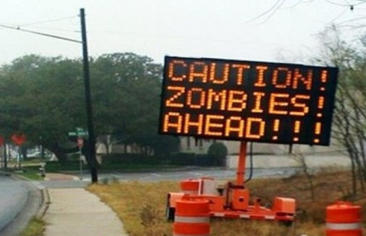
October
Tip of the Month


Preparing for the Zombies!

To celebrate the month of Halloween, it’s time to make sure you are prepared for the zombie apocalypse!
So what do you need to do before zombies…or earthquakes or pandemics for example, actually happen? First of all, you should have an emergency kit in your house. This includes things like water, food, and other supplies to get you through the first couple of days before you can locate a zombie-free refugee camp (or in the event of a natural disaster, it will buy you some time until you are able to make your way to an evacuation shelter or utility lines are restored). Take these steps:

1. Identify the types of emergencies that are possible in your area.
Besides a zombie apocalypse, this may include floods, tornadoes,
or earthquakes.
2. Pick a meeting place for your family to regroup in case zombies
invade your home…or you have to leave suddenly for other
reasons (earthquake, fire, etc.)
3. Identify your emergency contacts. Make a list of local contacts
like the police, fire department, and your local zombie response
team. Also identify an out-of-state contact that you can call
during an emergency to let the rest of your family know you are
ok.
4. Create a plan! When zombies are hungry they won’t stop until
they get food (i.e., brains), which means you need to be pepared! Plan
where you would go and multiple routes you would take ahead of time
so that the flesh eaters don’t have a chance!

For more information visit www.kitsapdem.org

